**Model Development Phase Template**

|  |  |
| --- | --- |
| Date | 14 June 2025 |
| Team ID | SWTID1749709340 |
| Project Title | Predicting Co2 Emission by countries Using Machine Learning |
| Maximum Marks | 4 Marks |

**Initial Model Training Code, Model Validation and Evaluation Report**

The initial model training code will be showcased in the future through a screenshot. The model validation and evaluation report will include classification reports, accuracy, and confusion matrices for multiple models, presented through respective screenshots.

**Initial Model Training Code:**

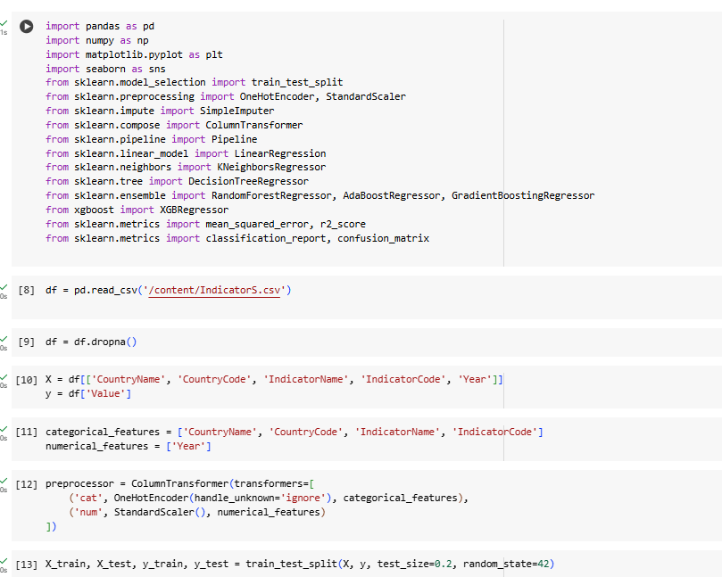

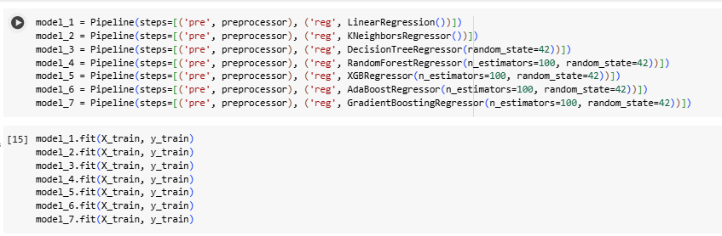

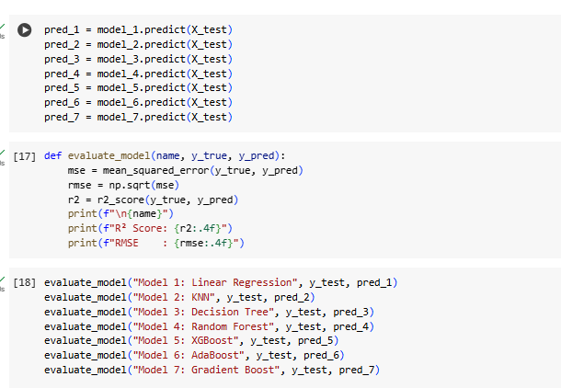

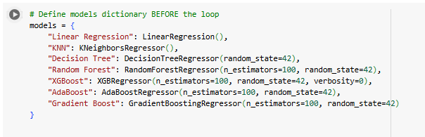

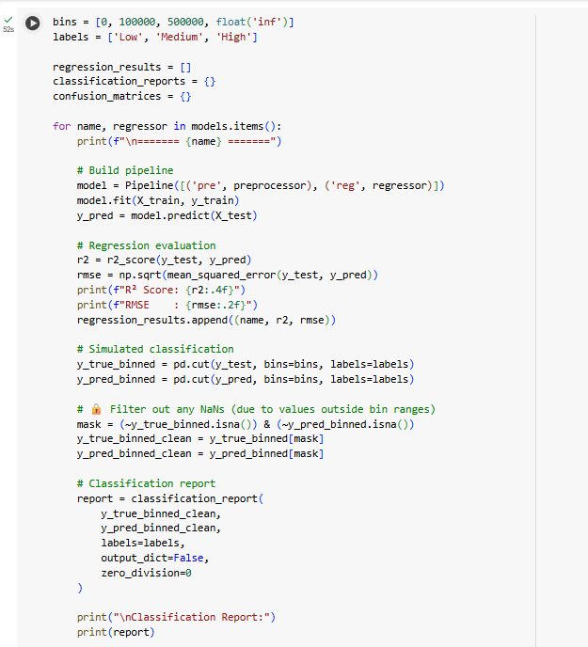

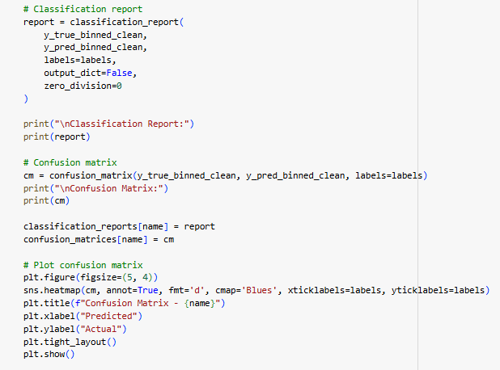

**Model Validation and Evaluation Report:**

|  |  |  |  |
| --- | --- | --- | --- |
| **Model** | **Classification Report** | **Rsquare score** | **Confusion Matrix** |
| Linear Regression |  | R² Score: 0.0301  RMSE : 13282867018179.9961 |  |
| KNN |  | R² Score: 0.2783  RMSE : 11458119062280.3848 |  |
| Decision Tree |  | R² Score: 0.8586  RMSE : 5071746744942.4941 |  |
| Random Forest |  | R² Score: 0.9985  RMSE : 7863224335477.2188 |  |
| XGBoost |  | Model 5: XGBoost  R² Score: 0.8598  RMSE : 5050634315628.5957 |  |
| AdaBoost |  | R² Score: -513.7526  RMSE : 305998691802595.8750 |  |
| Gradient Boost |  | R² Score: 0.6902  RMSE : 7506340843913.5820 |  |